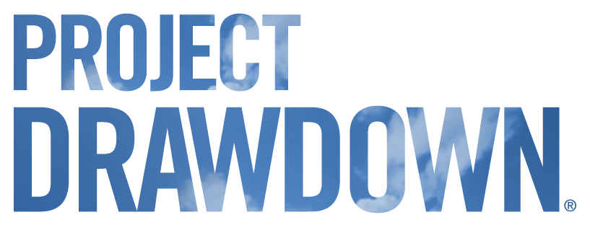

RESEARCH ANALYST - OCEAN SOLUTIONS
About the Position
We are currently recruiting for 1-2 Research analysts for Project Drawdown’s Oceans project. The primary goals of the Drawdown Oceans project are to:
- Create an Oceans data model that analyzes the potential for marine climate solutions to reduce emissions, sequester carbon, and improve economic and social outcomes; and, to integrate this model with existing sector models to expand the overall global systems analysis.
- Integrate the results from the oceans model into all drawdown communications, coalitions, and curriculum efforts.
- Regularly update the oceans model with the latest data and research to ensure its accuracy and usefulness to target audiences in perpetuity.
The result of this project will be that marine climate solutions will be known widely and publicly alongside already prominent sectors such as energy and transport, just as Project Drawdown has highlighted the impact of the agriculture and food sectors. Ultimately, this will further global understanding of the potential for marine solutions and drive investment and implementation in this crucial area.
Responsibilities
- Support data collection and methodology revision for Ocean solutions.
- Identify and scope new solutions and coming attractions for inclusion in future publications.
- Communicate with Senior Fellow for Oceans and Drawdown staff as needed.

Qualifications
- Completed Master’s degree required, PhD or equivalent work experience preferred. Candidates currently enrolled in a Master’s program will be considered in circumstances where the candidate’s course work will be centered on the subject matter of the fellowship.
- 5+ years of experience in sustainability, renewable energy, energy efficiency, bio-sequestration, land use, agriculture, international development, climate modeling, or related field.
- Experience in quantitative analysis, data modeling or econometrics required.
- Strong research, analysis and writing skills. Demonstrated ability to conduct research and produce scholarly work.
- Experience with preparing clear, compelling, and high-quality reports and presentations. Project management skills, capable of meeting deadlines.
- Interest in and ability to work remotely, yet in collaboration with a team of researchers in different time zones.
- Comfort with teleconferencing technologies. Ability to participate in videoconferences between the hours of 9:00 am – 12:00 pm Pacific Time.
The ideal candidate will have experience in interdisciplinary science and modeling and a desire to build on this as a researcher. The candidate will also be creative in linking scholarship with practice. Candidates should be vitally interested in climate solutions.
Start date: ongoing from July 1, 2019
Expected weekly hours: 30 - 40 hours
Length of contract: 3 months independent contract (open to renewal).
Location: Work may be conducted remotely worldwide.
Stipend: $3600/month

How Do I Apply?

Please apply here, where you can upload a cover letter, three professional references, a writing sample, and resume. In your cover letter, please highlight your experience with Oceans Solutions and your prior work with climate modelling.
Application deadline: Open until filled. Priority will be given to applications received before June 28, 2019.
For more information contact catherine.foster@drawdown.org or visit our website at www.drawdown.org

